Chapter 7, Solution 57.

At 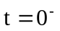, the circuit has reached steady state so that the inductors act like short circuits.

+
−
30 V
6 
5 
i₁
i
20 
i₂

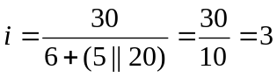, 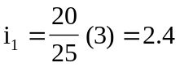, 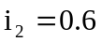
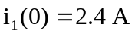, 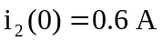

For t > 0, the switch is closed so that the energies in 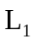 and 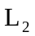 flow through the closed switch and become dissipated in the 5  and 20  resistors.
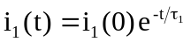, 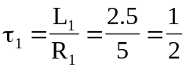

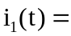2.4e^{–2t}u(t) A

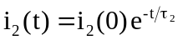, 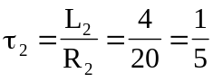

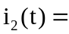600e^{–5t}u(t) mA

